This document is merely to point out the differences in confessional count numbers between my findings and the official numbers posted on Survivor Sucks. The guidelines I use can be found [here](https://docs.google.com/document/d/18ofsPiVWxSejzSjEGlU8KEx4Og2ddEJScCV23RsCPIA/edit?usp=sharing).

**Survivor Sucks Season 23 Counts** ([link](https://goo.gl/photos/vBxW8VmrDZnWE5u1A))

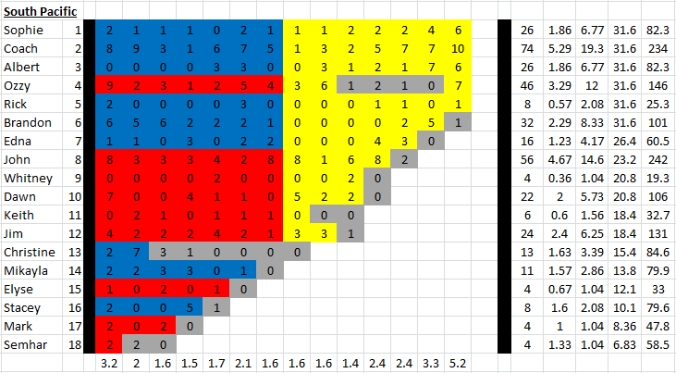

**My Season 23 Counts** ([link](https://goo.gl/photos/gHrZyBvNc2CgJpXx9))

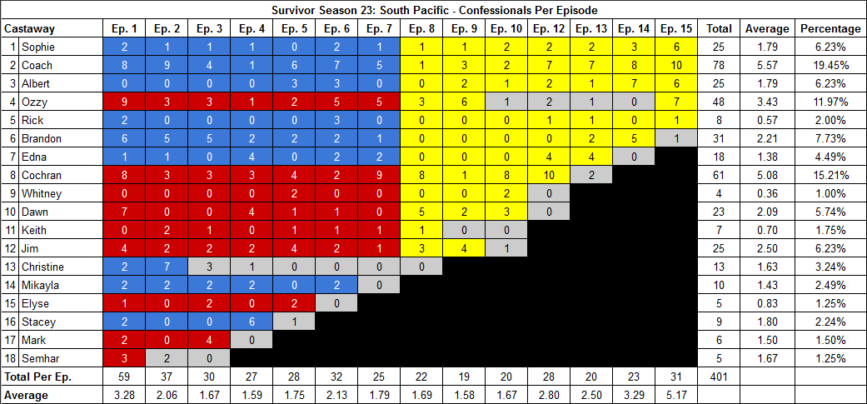

[Survivor Sucks Season 23 thread](http://survivorsucks.com/topic/86587).

**Note:** For Redemption Island themed seasons, I count confessionals post-TC, once castaways arrive at RI, which is a main difference from the guidelines used on Survivor Sucks.

**Differences**

[Episode 01](https://docs.google.com/document/d/1UjaQc4EPB7lyk-jSyINGNKpSCzn0LYxigDKzqxjMzG8/edit?usp=sharing)

* **Semhar: 3 (+1)** Confessional #59 is a RI confessional.

[Episode 02](https://docs.google.com/document/d/1Mcazg_2Wu6HmTzhjDtfmPu7zCDHWXEjwU918iBd3olQ/edit?usp=sharing)

* **Ozzy: 3 (+1)** Confessional #11 is an on-the-fly confessional. It has Ozzy strolling through the jungle as he searches for the HII and he narrates what he is doing to the camera as he does so.
* **Note:** Christine has an established count of 7 for this episode. In order to arrive at that count, her sole RI confessional (voice over) has to be counted. Otherwise, she would have a count of 6.

[Episode 03](https://docs.google.com/document/d/1QmknS5t2FtmvFn_uBlCMcrl1Z_GkEQ7ZZtyxTBWvjz4/edit?usp=sharing)

* **Coach: 4 (+1)** In this episode, I counted 4 confessionals for Coach. Confessional #5 has a 9s gap. Confessional #10 has a 14s gap.
* **Brandon: 5 (-1)** In this episode, I counted 5 confessionals for Brandon instead of the established 6. None of his confessionals have significant time gaps.
* **Mikayla: 2 (-1)** In this episode, I counted 2 confessionals for Mikayla instead of the established 3. None of her confessionals have significant time gaps.
* **Mark: 4 (+2)**
  + Confessional #25 has Mark narrating to the camera (without looking directly at it) while he makes a fake HII. He narrates what he is doing and his plan with it.
  + Confessional #30 is a RI confessional.

[Episode 04](https://docs.google.com/document/d/1FQKEQqLcbLSmFVlBRt3jXcZcW9HwCsbXeh9qIICTwJU/edit?usp=sharing)

* **Edna: 4 (+1)** In this episode, I counted 4 confessionals for Edna instead of the established 3. Confessional #12 has a 13s gap.
* **Mikayla: 2 (-1)** Confessional #15 has a 9s gap.
* **Stacey: 6 (+1)** Confessional #27 is a RI confessional.

[Episode 05](https://docs.google.com/document/d/1W_sV-3GXiY5_KhBW51yl1ts5c5A4hXHOTNvfNIewXnM/edit?usp=sharing)

* **Elyse: 2 (+1)** Confessional #28 is a RI confessional.

[Episode 06](https://docs.google.com/document/d/1gWfYJuQbN90wgx0Cu-wO_F5gKiw8hQH_zgHWgD-P2vg/edit?usp=sharing)

* **Mikayla: 2 (+1)** Confessional #32 is a RI confessional.

[Episode 07](https://docs.google.com/document/d/1SowqkvU60Iu8KGNDd4Y4LIv9fQXelOAR9msjJvbBL_M/edit?usp=sharing)

* **Cochran: 9 (+1)** Cochran has two sets of consecutive confessionals that have gaps of 11s each. They are #18 and #21.
* **Ozzy: 5 (+1)** Confessional #25 is a RI confessional.

[Episode 08](https://docs.google.com/document/d/1gNKa5bcPTvDLCY_4YUpA4EHd6oj9FTY1F74tnwgpdl4/edit?usp=sharing)

* **Keith: 1 (+1)** Confessional #22 is a RI confessional.

[Episode 09](https://docs.google.com/document/d/10kNuAoQpSiwNM9FxVMr4fNCoSi9q64L-l3MCiugVsqQ/edit?usp=sharing)

* **Albert: 2 (-1)** In this episode, I counted 2 confessionals for Albert instead of the established 3. None of his confessionals have significant time gaps.
* **Jim: 4 (+1)** Confessional #19 is a RI confessional.

[Episode 10](https://docs.google.com/document/d/1J8_z_u9Mw4e08bqE2sQGc8okmYPFTzDkYZk0PnDXWqw/edit?usp=sharing)

* **Cochran: 8 (+2)** Cochran has two sets of consecutive confessionals, each with 10s gaps. They are #7 and #15.
* **Dawn: 3 (+1)** Confessional #20 is a RI confessional.

[Episode 12](https://docs.google.com/document/d/13GxGxxNKSY8Sa2C0pqPC7ymU94l1l3rbbj2GW4ovZvQ/edit?usp=sharing)

* **Cochran: 10 (+2)**
  + Cochran has 2 sets of consecutive confessionals with significant time gaps.
    - Confessional #3 has a 10s gap
    - Confessional #6 has a 13s gap
  + Confessional #28 is a RI confessional.
* **Coach: 7 (+2)** For Coach in this episode, I counted one on-the-fly confessional, and disregarding that, I still got 6 regular confessionals which is an additional count than the established 5 for him.
  + Confessional #15 is a brief on-the-fly confessional where Coach walks through the jungle and narrates to the camera giving his opinion of Albert.

[Episode 13](https://docs.google.com/document/d/1iLvLQPJXzJB7t1GNaF671lYIpfv26NP2n0RaXOAdbTw/edit?usp=sharing)

* **Edna: 4 (+1)** Confessional #20 is a RI confessional.

[Episode 14](https://docs.google.com/document/d/1JvwL5MfCxFTGdK-ov8J1kGEhdAKBjzzjJv84vfxdMXA/edit?usp=sharing)

* **Coach: 8 (+1)** Confessional #12 is an on-the-fly confessional in which Coach is talking directly to the camera, but Brandon interrupts him and he stops.
* **Sophie: 3 (-1)** Confessional #18 has a 9s gap.
* **Note:** Regarding Brandon, I counted one RI confessional (#23) which gives me a total of 5 which is the same as the original count. So either that RI confessional was originally counted, or there was a 9s gap from confessional #20 that was missed, which would give him a -1 for this episode.

**No Change**

* [Episode 15](https://docs.google.com/document/d/1RVaxjEPch83rkNxZFsOgregTYVNkEImTCR9V9tr0nsY/edit?usp=sharing)

|  |  |  |
| --- | --- | --- |
| **Castaway** | **Count (RI in parenthesis)\*** | **Change** |
| Sophie | 25 | -1 |
| Coach | 78 | +4 |
| Albert | 25 | -1 |
| Ozzy | 47 + (1) = 48 | +2 |
| Brandon | 31 | -1 |
| Edna | 17 + (1) = 18 | +2 |
| Cochran | 60 + (1) = 61 | +5 |
| Dawn | 22 + (1) = 23 | +1 |
| Keith | 6 + (1) = 7 | +1 |
| Jim | 24 + (1) = 25 | +1 |
| Mikayla | 9 + (1) = 10 | -1 |
| Elyse | 4 + (1) = 5 | +1 |
| Stacey | 8 + (1) = 9 | +1 |
| Mark | 5 + (1) = 6 | +2 |
| Semhar | 4 + (1) = 5 | +1 |
| **Total** | **401** | **+17** |

*\*In this column, the number in parenthesis corresponds to any post TC RI confessionals I counted, and the equal corresponds to my final total for that castaway, which is also reflected in the overall change in the third column. If you don’t count RI confessionals, the total number for the castaway will be to the left of the parenthesis.*

**Revised Sucks Counts** ([link](https://goo.gl/photos/pNSc9nnGibrDYm2v5))

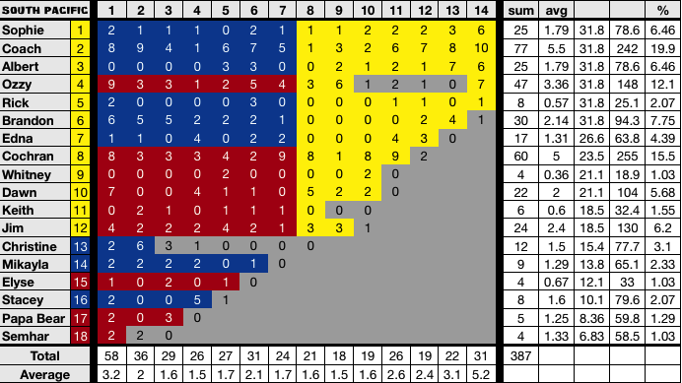

**Differences**

Most changes were accepted except for:

* All Redemption Island post-credit confessionals were not included (-13).
* Confessional #15 from Ep12 isan on-the-fly Coach confessional that was not included (-1).